Single Ended to fully differential Conversion

Most of the SciCompiler supported board require fully differential signaling to correct operate.

Differential signaling is a method for electrically transmitting information using two complementary signals. The technique sends the same electrical signal as a differential pair of signals, each in its own conductor. The receiving circuit responds to the electrical difference between the two signals, rather than the difference between a single wire and ground.

Provided that the source and receiver impedances in a circuit are equal (it is balanced), external electromagnetic interference tends to affect both conductors identically. Since the receiving circuit only detects the difference between the wires, the technique resists electromagnetic noise compared to one conductor with an un-balanced reference (low-Ω connection to ground).

Due to immunity to the noise, differential signals allows to transport the analog signals from tens of meters on standard and cheap CAT5e/CAT6 cables without any signal degradation.

This application notes include information and circuit to convert single ended signal from radiation detector to signal that can be easy digitalized with the DT5500 or R5560.

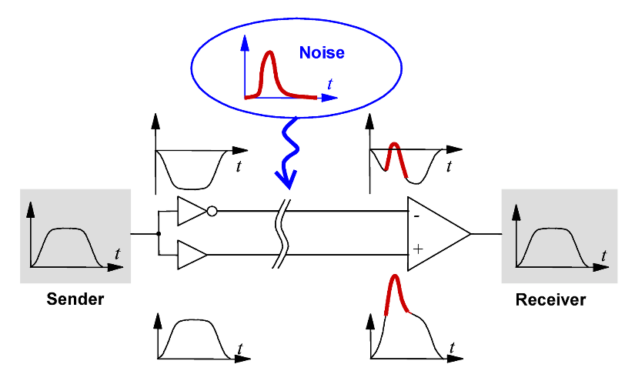

Single Ended to Differential Conversion

In order to convert a single ended signal in a fully differential one, a fully differential Operational Amplifier is required

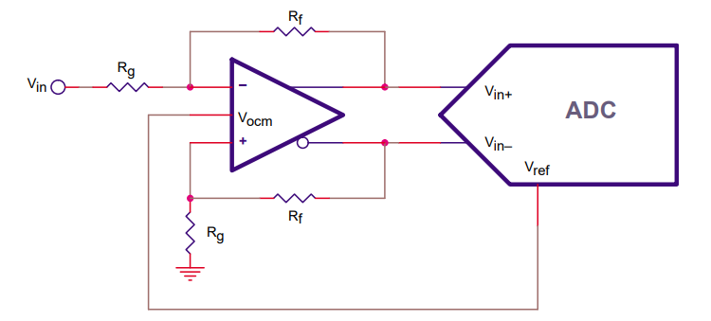

The signal input Vin is converted in a differential signal on the output Vout+- on the common mode voltage Vref thanks to the op-amp pin Vocm

The diff-amp in figure is configured for a differential gain of one, so the circuit’s transfer function is

VOUT, DIFF = VOP – VON = VIN.

The output common-mode voltage, (VOP + VON)/2, is set by the voltage on the VOCM pin.

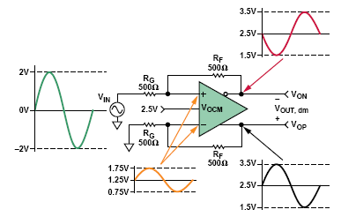

Regulate offset of the output signal

Usually input signal from radiation detector use just half of the voltage swing. Typically, the signal is only positive or negative.

Following circuit allows to translate the single ended input in a fully differential signa exploiting the fully dynamic of the ADC.

It very important to drive the OFFSET pin with a low impedance in order to maintain balanced the stadium

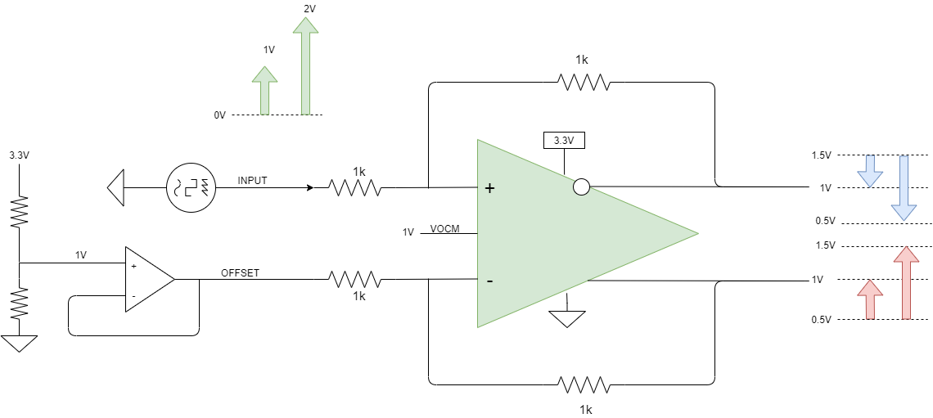

Terminating input signal

If it is necessary to terminate input signal with a 50R termination, the following scheme can be used

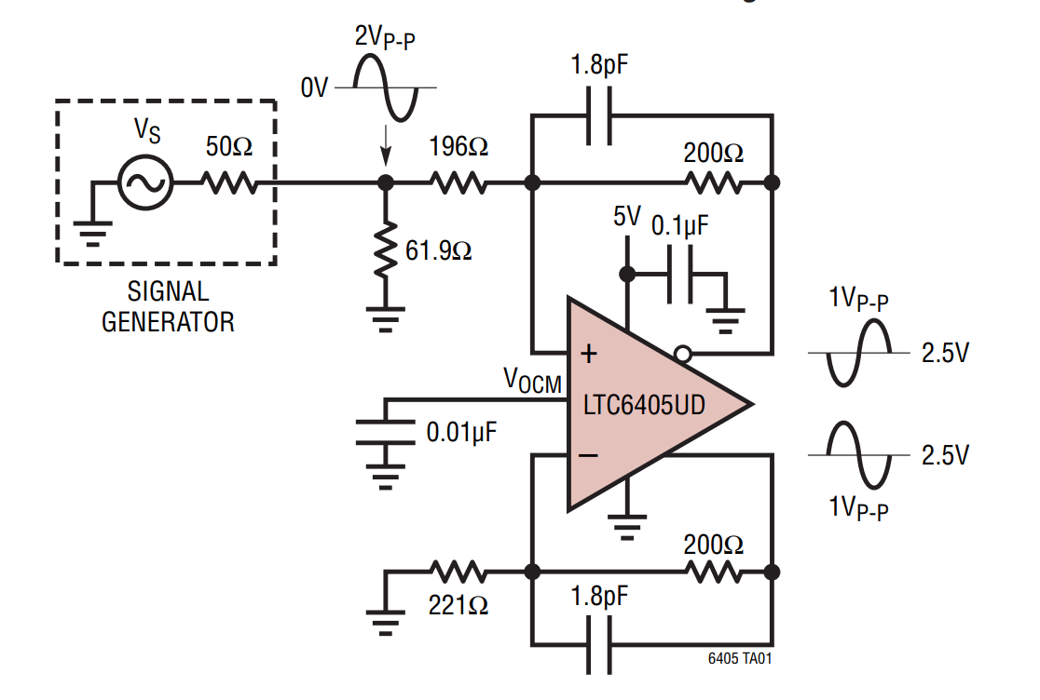

Considering that the V+ of the fully differential op-amp is a virtual ground, the input impedance seen by the signal generator is 50R. The 221R resistor is chosen to match on the V- input the impedance of the V+ input: 196R + (61.9R // 50R) = 221R

Multichannel converter FOR R5560 reference design

The THS4524 is a 145MHz, fully differential op-amp with quad channels in a single package. Its configuration perfectly match the R5560 differential quad channel input.

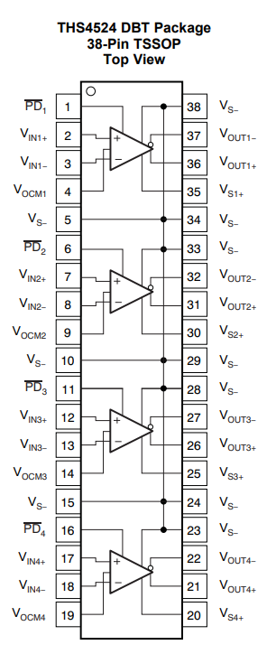

An Altium design schematic of a 32 channel driver stage for the R5560 is available on github:   
<https://github.com/NuclearInstruments/SingleEndedToDifferential>

The reference design is suitable to direct drive the R5560 converting signal from single ended to differential with no offset. It can be downloaded ad used as a starting point for a custom design

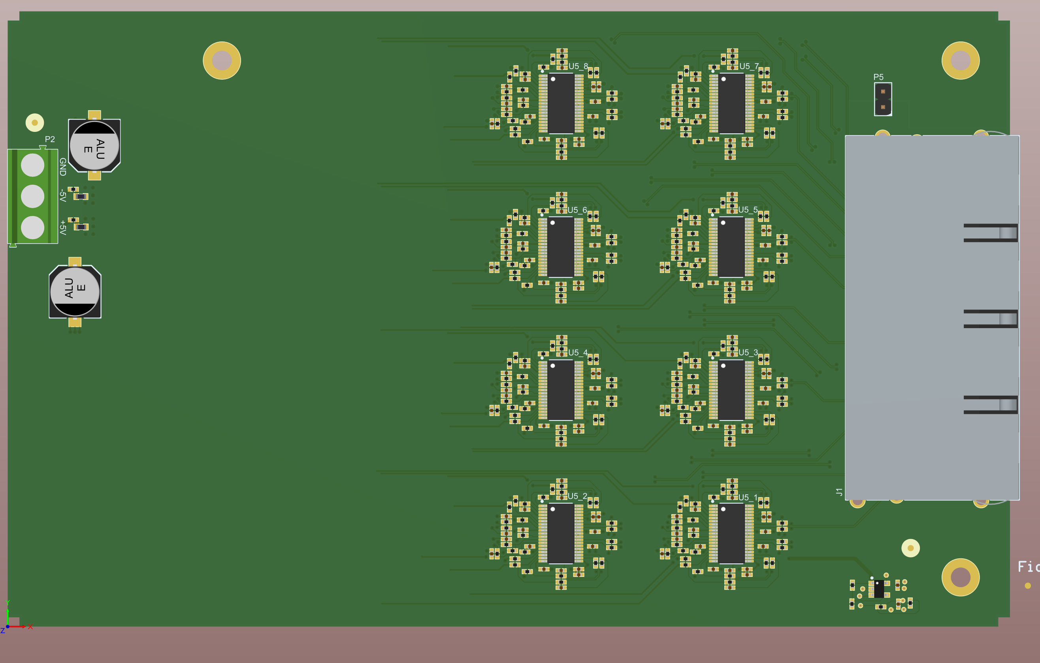 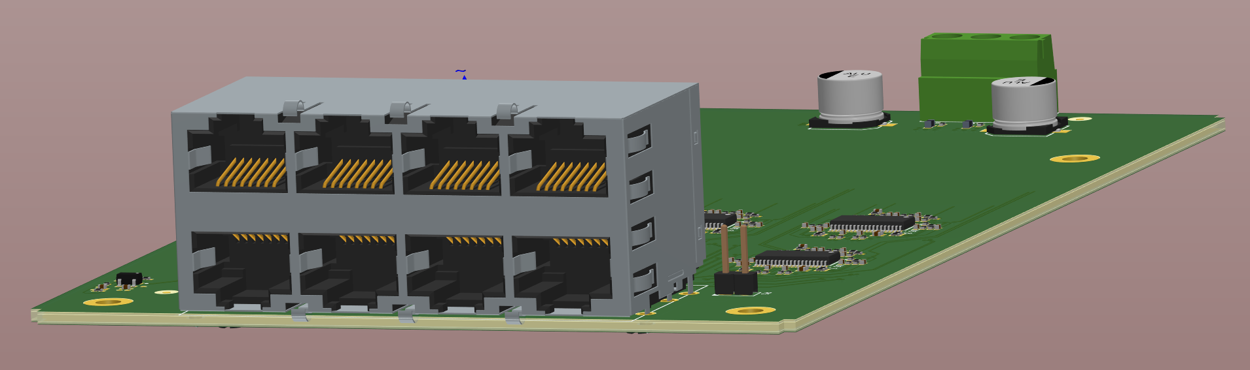

DT5550 Analog Input pinout

The pinout of the frontal analog connector is shown in figure. Differential analog lines are indicated in red and the polarity is marked by the “_P” and “_N” label in the pin name.

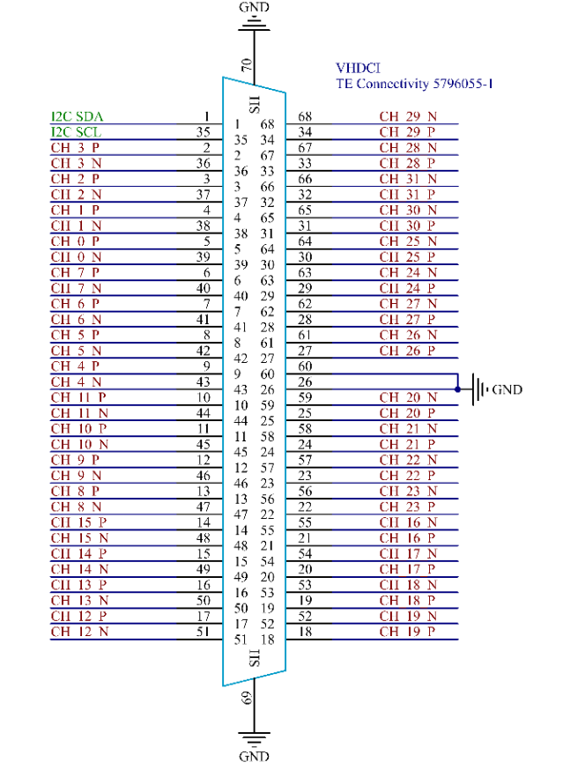

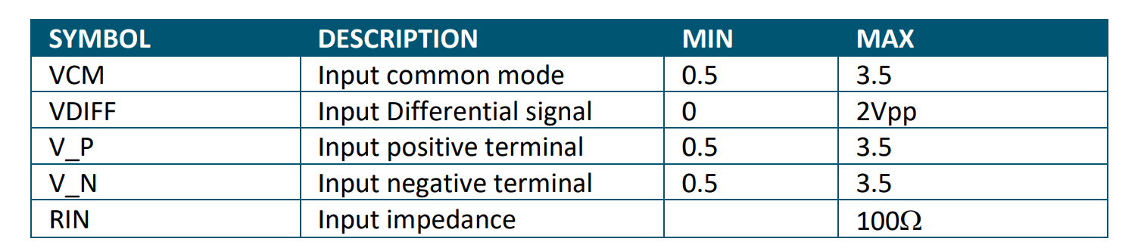

We strongly suggest to use a VCM voltage between 0 and 1V for maximum performance

Connector Series: VHDCI connector Type: 71430-0008

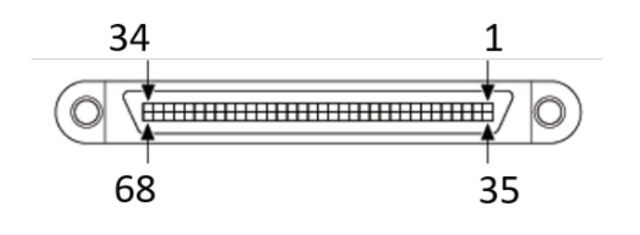

R5560 Analog Input pinout

The system is divided in four DAQ sections, each with 32 input channels and a dedicated FPGA. The frontal panel clearly identifies the analog channels, grouping them with the relative digital signals, Ethernet connectors and SFP+ links. The different sections can easily communicate each other thanks to fast horizontal links.

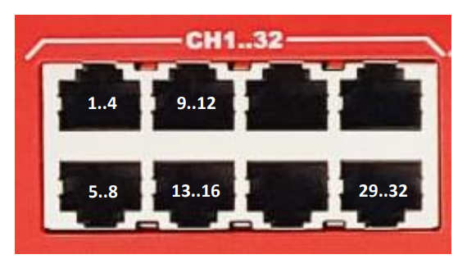

he R5560 has four groups of 8x RJ45 shielded connectors to carry analog signals. The pinout of the analog connector is shown in Figure below. The R5560 analog connector follows the standard pinout of the ethernet connectors. This allows to use standard CAT5e pre-crimped cables to connect pre-amplifiers to the board.

